CSC 271 Data Structures
Assignment 3

Notes:

Criteria | Exemplary | Satisfactory | Marginal | Deficient
Flexibility of Design
Documentation of Design
Implementation
Testing

Assume double type for your data.

2.5 + 2 * ( 2.0 + 4 ) / 2.5

If variables?
x = 4.5
y = 2.5

2.5 + x * ( y + 3 ) / 3

To convert the input string to tokens use the standard string tokenize class.
In your input string you may have doubles, variable identifiers, operators and braces. To simplify tokenizing you may decide to impose a certain syntax of your string: use one space “ “ between tokens as a delimiter.
If you use variable identifiers, you may decide to pass to your class the string and two parallel vectors (table) one of strings (with variable names) and vector of string (doubles with relevant values for your variables – see functions to convert from double to string. You will need also a function to convert from string to double).
Replace the variable names in the tokenized vector of string with the string of their values.
You may decide first to implement expression evaluation with no variable identifiers and then to expand it to accept identifiers. The same method (constructor) can be used using default parameters (vectors).

One possible solution is to first convert your expression from infix to postfix using the algorithm considered in class (applied to strings, not to characters). During tokenization you can store the tokens into a vector of strings (vector class – similar as the Vector in Java; find the description).

The rules to convert an infix expression into an equivalent postfix expression are as follows:

- Scan the expression (vector) from left to right. One pass is sufficient.
- If the next scanned string is an operand, add it to the postfix expression (vector of strings).
- If the next scanned string is a left parenthesis, push it onto the stack.
- If the next scanned string is a right parenthesis, pop and append all the strings from the stack until the most recent left parenthesis. Pop and discard the left parenthesis.
- If the next scanned string is an operator:
- Pop and append every operator from the stack that is above the most recently scanned left parenthesis and that has precedence greater than or equal to the new operator.
- Push the new operator onto the stack.
- After the infix string is completely processed, pop and append to the postfix vector of string everything from the stack.

In this program, you are to consider the following (binary) arithmetic operators: +, -, *, and /.
You assume that the expressions you process are error free (if incorrect data – return -1 with appropriate message to the user).

Evaluate the postfix expression using the algorithm, considered in class.

Postfix Evaluation
􀂄 To evaluate a postfix expression, execute the following steps until the end
of the expression.

1. If recognize an operand, push it on the stack.
2. If recognize an operator, pop its operands, apply the operator and push the value on the stack.
3. Upon conclusion, the value of the postfix expression is on top of the stack.

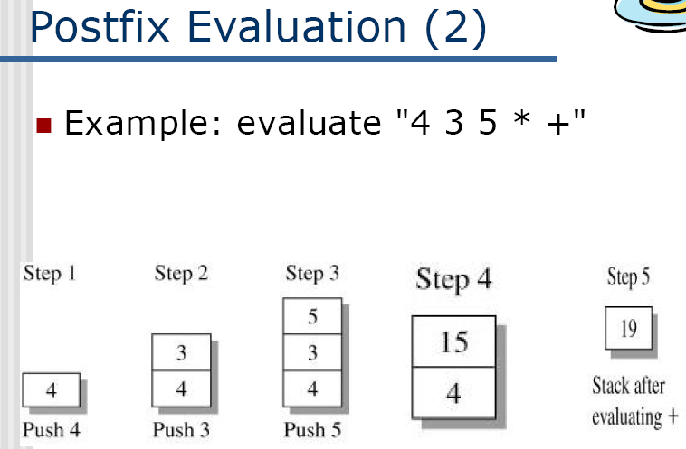

Make your implementation flexible and easy to accommodate more operators:

Operator | Type | Precedence | Description
+ | binary | 4 | addition
- | binary | 4 | subtraction
* | binary | 5 | multiplication
/ | binary | 5 | division
mod | binary | 5 | remainder
^ | binary | 6 | exponentiation
! | right unary | 6 | factorial
% | right unary | 6 | percentage
abs | unary | 6 | absolute value
trunc | unary | 6 | truncation
round | unary | 6 | rounding
sin | unary | 6 | sine
cos | unary | 6 | cosine
ln | unary | 6 | natural logarithm
log | unary | 6 | common (base-10) logarithm
lg | unary | 6 | base-2 logarithm
exp | unary | 6 | natural exponential (e^{k})
sqr | unary | 6 | square (k²)
sqrt | unary | 6 | square root

Xtra credit check for input errors and handle exceptions.
See <ctype.h> and <string.h>

STL class stack
(Stack Container Adapter)
- Standard Template Library (STL) provides a class to implement a stack in a program
- Name of the class defining a stack is stack
- Name of the header file containing the definition of the class stack is stack
Example:
#include <stack>

stack<char> charStack ;
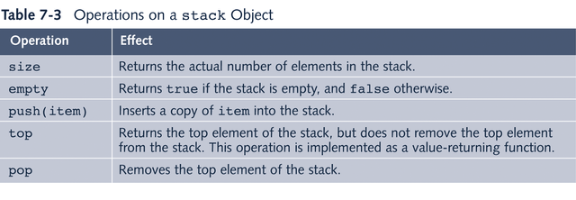
In STL systems stack is implemented as an adapter to a container. Container is a generic data type and different implementations are available: using vector, list, or deque (double ended queue). You can also create stack objects with next statements:
stack<char, vector<char>> charStack ;
stack<char, list<char>> charStack ;
stack<char, deque<char>> charStack ;
OR
stack<vector<char>> charStack ;
stack<list<char>> charStack ;
stack<deque<char>> charStack ;

Algorithm with two stacks and no conversion to postfix.

Using 2 stacks you can evaluate an infix expression in 1 pass without converting to postfix first:

Algorithm
- Create an empty operator stack
- Create an empty operand stack
- Repeat
3.1 Get the next token in the infix string
3.2 If next token is an operand, place it on the operand stack
3.3 If next token is an operator
3.3.1 Evaluate the operator (next op)
Until at the end of the string
4. while operator stack is not empty
pop operator and operands (left and right),
evaluate left operator right
and push result onto operand stack
5. Pop result from operator stack

Algorithm with further refinement.

data fields:
2 stacks
boolean inNumber; // processing a number
int numValue; // value of number being processed.

public int scanInfixString(String infix)
boolean inNumber = false;
int numVal = 0;
for each character position in infix {
nextChar = charAt(i);
if nextChar is a digit
processDigit(nextChar);
inNumber = true;
else if nextChar is an operator
processOperator(nextChar);
}
popAndEvaluateAllOperators();
int result = ((Integer) operands.pop()).intValue();
if (operands.empty() && operators.empty())
return result;
else
return -9999;
} // end scanInfixString

public void processOperator (char nextOp)
Set done to false
// check if number was just processed. If so,
// push it on operand stack.
if (inNumber)
operands.push(new Integer(numValue));
inNumber = false;
numValue = 0;
}
// Process the operator now
Repeat
If operator stack is empty or next op is ‘(‘,
push next op onto stack and set done to true
Else {
char topOp = ((Character) operators.peek()).charValue();
if precedence(next op) > precedence(top operator)
Push next op onto the stack (ensures higher precedence operators evaluated first)
and set done to true
Else
Pop the operator stack
If operator popped is ‘(‘,
set done to true.
Else
pop right and left from operand stack
evaluate left operator right
push result onto operand stack
until done
} // end processOperator

public void processDigit(char dig) {
numVal = 10 * numVal + (int) dig - (int) '0';
}
Rubric for Evaluation

Criteria | Exemplary | Satisfactory | Marginal | Deficient
Flexibility of Design | The design of the class interface makes apparent how the class allows a wide variety of expressions involving variables, constants, and a rich set of operators. | The design of the class interface allows some variety of expressions involving variables, constants, and operators. However, for some applications the constraints imposed on the kinds of expressions would make use of the class awkward. | The design of the class interface limits the use of the class to a very narrow type of application, without being readily adaptable to other applications. | The design of the class interface is so flawed that it cannot be easily used in any application.
Documentation of Design | The documentation for class constructors and functions (methods) accurately and in great detail specifies how a client program would instantiate objects and call on the operations provided by an object instance of the class. | The documentation for class constructors and functions (methods) correctly specifies how a client program would instantiate objects and call on the operations provided by an object instance of the class. However, for a small number of the operations, the documentation should provide more details regarding their use by a client program. | The documentation for class constructors and functions (methods) specifies in overly general terms how a client program would instantiate objects and call on the operations provided by an object instance of the class. As a result the developer of such a client program would often have questions regarding the return value of the function or regarding the role of particular function parameters. | The documentation for class constructors and functions (methods) is often incorrect or stated in such vague terms as to be of no help to the developer of a client program that would want to use the class.
Implementation | The implementation of the class is carried out in elegant fashion with the details of implementation being appropriately hidden from client programs that would use the class. All methods work as specified in their documentation. | For most of the operations of the class, the implementation is carried out in appropriate fashion with implementation details largely hidden from a client program. However, in a few situations, the implementation is done awkwardly or in a way that exposes details of the implementation to a client program. Nonetheless all methods work as specified in their documentation. | Relatively few of the operations of the class are implemented in a fashion that is as simple as possible. As a result, implementation details are often unnecessarily exposed to client programs and some operations have flaws that lead to errors. | Almost all of the operations of the class are implemented incorrectly, with the result that the class is essentially unusable from a client program's perspective.
Testing | A thorough set of test cases with expected results is developed for each of the operations provided by the class. There is broad coverage of all the logical possibilities that each operation might encounter. | Test cases with expected results are developed for each of the operations provided by the class. However, occasionally a relatively small number of logical possibilities that might be encountered by an operation are omitted in the coverage provided by the test cases. | Test cases with expected results are developed for each of the operations provided by the class. However, these test cases often leave uncovered a significant number of logical possibilities that operations of the class might encounter. | The test cases are very inadequate both in their specification of the expected results for each case and in the logical coverage they provide for the operations of the class.

